**Adding Swagger Documentation to ASP.NET Core Web API Project**

1. Create new .NET Core Web API project.
2. Open the .**csproj** file and add the **“swashbuckle.aspnetcore”** package reference.

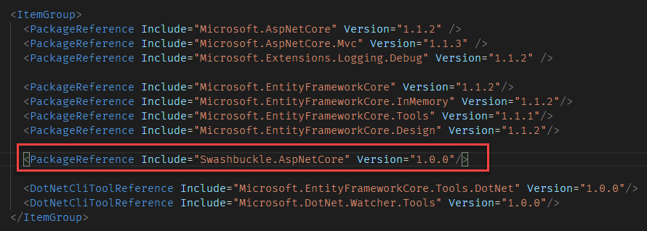

1. Restore the packages using the “**dotnet restore**” command.
2. Add the service to the **ConfigureServices** method of the **Startup** class.

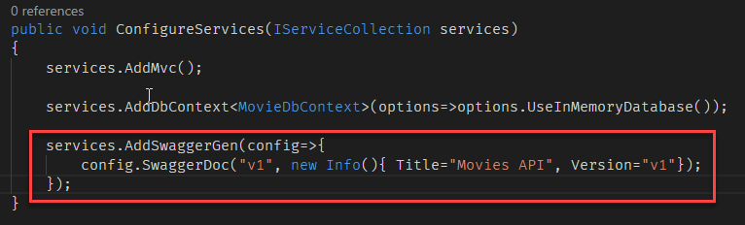

1. In the Configure method, insert middleware to expose the generated Swagger as JSON endpoint(s)

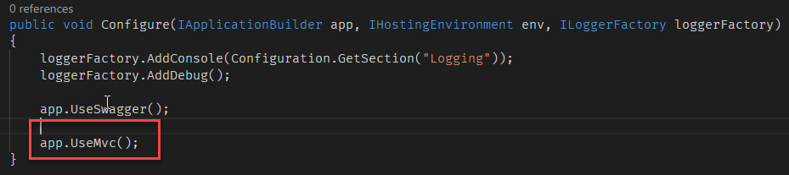

1. At this point, you can spin up your application and view the generated Swagger JSON at **"/swagger/v1/swagger.json."**

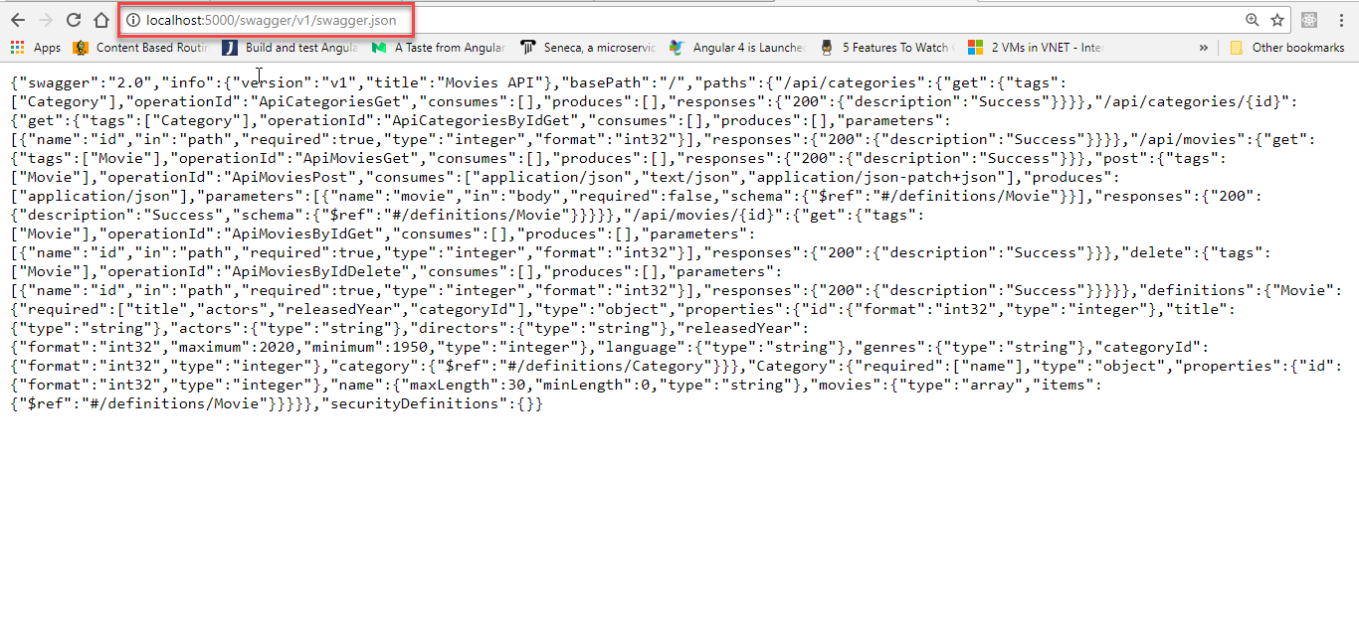

1. Optionally insert the swagger-ui middleware if you want to expose interactive documentation, specifying the Swagger JSON endpoint(s) to power it from.

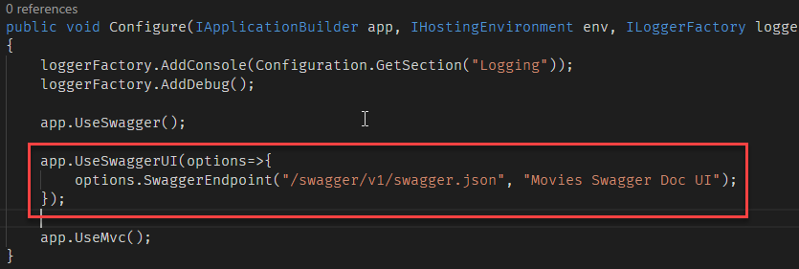

1. Now you can restart your application and check out the auto-generated, interactive docs at **"/swagger".**

